Power Gauge – Virtual - BEV – CGEA1.3

Functional Description

The instrument cluster shall display the amount of power delivered to the wheel for propulsion (tractive effort). The delivered power includes only the electrical power delivered to the electric motor. It excludes the electrical loss and accessory loads. Sign convention is such that power being delivered to the wheels is positive and power from regenerative braking is negative.

In addition, Instrument cluster shall also display Power available based on a CAN signal from the Hybrid Powertrain Control Module (HPCM) in the form of a bar gauge. The Power gauge behavior between 0-100% shall be linear. Available Power gauge fill will share common bar with power gauge on positive side.

The purpose of the Power Gauge is to engage the driver, by providing the following information:
- The total power delivered to wheel
- The negative power (‘harvesting power’ or ‘Charging’) when it is in regen. (on applicable programs)

The Power Gauge correlates the PwWhlLvl_Pc_Dsply, EffRgenThres_Pc_Dsply and BattTracPw_Pc_Avail signals and the Operational Mode to generate a gauge indication.

The power gauge shall have an animation when a calibratable level of regen have been met. HPCM will handle this logic and transmit RgenAnimation_B_Dsply to inform animation status to IPC. IPC shall turn on the regen animation when RgenAnimation_B_Dsply = 0x1 and turn off when RgenAnimation_B_Dsply = 0x0, missing or invalid.

Interfaces

Interface Context Diagram

Inputs

IR-REQ-384929/A-Internal
  - Operational_Mode

MUX messages on the CAN Network

SIG-REQ-384914/A-PwWhlLvl_Pc_Dsply Signal

Signal Name | Size (bits) | Detail | Units | Res. | Offset | State Encoded | Min | Max
PwWhlLvl_Pc_Dsply | 10 | Electrical power to wheels | % | 0.2 | 0 |  | -102.2  (0x0) | 102.4 (0x3FF)
*
This is a signed signal.

Signal values from 0x0 through 0xA are to be treated as Min Cap (-100%)

Signal values of 0xB through 0x3F3 map to 0% through 100%

Signal values from 0x3F4 through 0x3FF are to be treated as Max Cap (100%)

PwWhlLvl_Pc_Dsply presents the amount of power delivered to the wheel for propulsion (tractive effort). The delivered
power includes only the propulsive mechanical power of electric motor for BEV configured powertrain. It excludes the
electrical loss and accessory loads. Sign convention is such that power being delivered to the wheels is positive and
power from regenerative braking is negative.

SIG-REQ-384915/A-BattTracPw_Pc_Avail (CAN) Signal

Signal Name | Size (bits) | Detail | Units | Res. | Offset | State Encoded | Min | Max
BattTracPw_Pc_Avail | 8 |  | Percentage | 0.5 | 0 |  | 0 (0x0) | 126.5 (0xFD)
 |  | No Data Exists |  |  |  | 0xFE
 |  | Faulty |  |  |  | 0xFF

SIG-REQ-386425/A-EffRgenThres_Pc_Dsply CAN signal

Signal Name | Size (bits) | Detail | Units | Res. | Offset | State Encoded | Min | Max
EffRgenThres_Pc_Dsply | 10 | Regenerative Power | Percentage | 0.1 | -102 |  | -102.3 | 0

SIG-REQ-389222/A-RgenAnimation_B_Dsply Signal

Signal Name | Size (bits) | Detail | Units | Res. | Offset | State Encoded | Min | Max
RgenAnimation_B_Dsply | 1 |  | unitless | 1 | 0 |  | 0  (0x0) | 1  (0x1)
 |  | Inactive |  |  |  | 0x0
 |  | Active |  |  |  | 0x1

IR-REQ-385038/C-Out puts
Power Gauge Indication
Power Availability Indication
Regen Power Indication
Power Gauge Animation

Function/Performance

F-REQ-384928/A-Operational Modes

Mode | Differentiating Vehicle Conditions
Sleep Mode | Power Gauge Not available
Limiting Mode | Power Gauge Not Available
Normal Mode | Power Gauge Functional
Crank Mode | Power Gauge Functional

Voltage Levels

Refer to Cluster Features table located in the Operational Modes and Voltage Range Strategies Section of this SPSS.

Human-Machine Interface

Visual

Indicator Graphics / Display Format
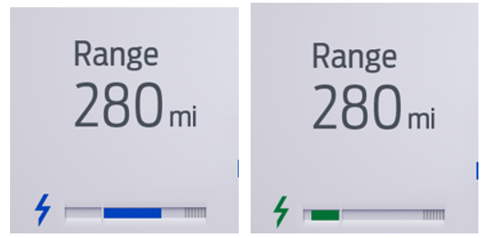
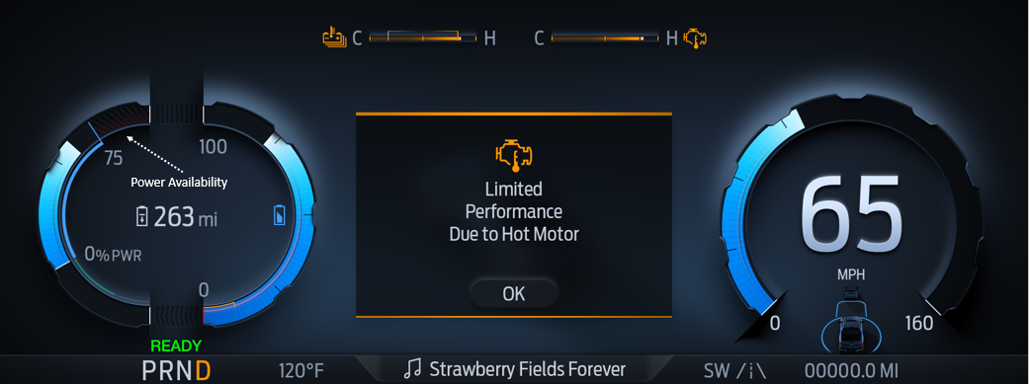

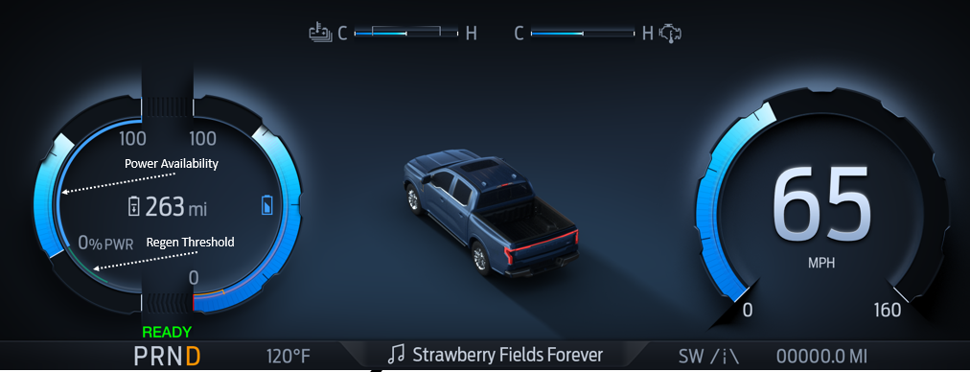

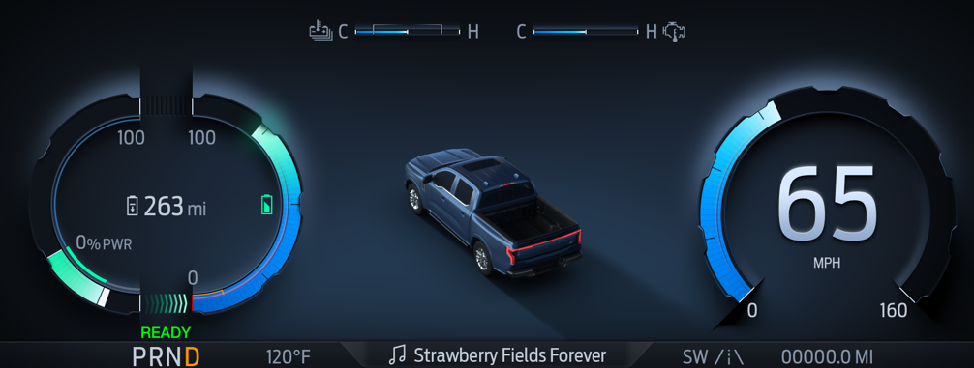
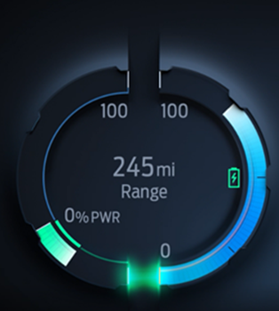
P702-BEV-Animation On

These are only sample graphics, please refer HMI specifications for program specific details.

Indicator Color Coordinates

None.

Indicator Characteristics

None

Audio

None

Switch Control Logic

Not Applicable

System Accuracy

PFM-REQ-384925/A-Sys_Acc_Req1

The Power Gauge Indication value shall be calculated within 100 msec of receiving a valid CAN Signal value.

PFM-REQ-384926/A-Sys_Acc_Req2

For a steady state input, the Power Gauge shall position its pointer on the input value with a tolerance of + / - 2 angular degrees.

PFM-REQ-384924/A-Sys_Acc_Req3

The Power Gauge Indication shall not lag the CAN Signal Input by a time greater than 300 msec.

Operation: Performance and Functional

Subsystem Algorithm Flowchart / State Diagram

F-REQ-384916/A-Flowchart for CAN Diagnostic Configuration Routine

F-REQ-385041/B-Power Gauge Process with Regen

F-REQ-384918/B-Gauge Indication for Power Gauge with Regen(Cx727 Specific)

Operational  _Mode | China_BEV_  _xHEV_Cfg | PT_Hyb_Cfg2 | PwWhllvl_Pc_Dsply  Signal | Power Gauge  Indication
Normal/Crank | 0x1  (China) | 0x1  (BEV) | -102.2 to <0 | Fill bar on left side of Gauge. Fill linear based on CAN input starting from center.  Fill Green
Normal/Crank | 0x1  (China) | 0x1  (BEV) | >=0 to 102.4 | Fill bar on Right side of Gauge. Fill linear based on CAN input starting from center. (Fill Blue)  Gauge Fill not intercept power availability Fill.
All Other Cases |  |  |  | Gauge with No Fill

F-REQ-384919/B-Gauge Indication for Power Availability Gauge(Cx727 Specific)

Operational  _Mode | China_BEV_  _xHEV_Cfg | PT_Hyb_Cfg2 | BattTracPw_Pc  _Avail  Signal | Power Availability  Indication
Normal/Crank | 0x1  (China) | 0x1  (BEV) | 0x00  To  0xFD  (Valid Range) | Fill bar on Right side of Gauge starting from right side.  Fill linear based on CAN input (BattTracPw_Pc  _Avail).  (Fill with Gray Shaded area)
All Other Cases |  |  |  | Gauge with No Fill

F-REQ-386420/A-Gauge Indication for Power Gauge with Regen (Default- All programs except Cx727)

Operational  _Mode | PT_Hyb_Cfg2 | PwWhllvl_Pc_Dsply  Signal | Power Gauge  Indication
Normal/Crank | 0x1  (BEV) | -102.2 to 102.4 | Fill linear based on CAN input. Gauge  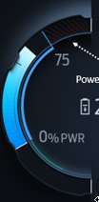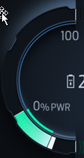  Positive Fill Negative Fill  Sample Graphics for reference
All other cases |  |  | Gauge with No Fill

F-REQ-386422/A-Gauge Indication for Regen Threshold Indication (Default- All programs except Cx727)

Operational  _Mode | PT_Hyb_Cfg2 | EffRgenThresh_Pc  _Dsply | Power Gauge  Indication
Normal/Crank | 0x1  (BEV) | -102.3 to 0 | Fill linear in Regen area based on CAN input.  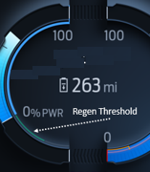  Sample Graphics for reference
All Other Cases |  |  | Gauge with No Fill

F-REQ-386424/A-Gauge Indication for Power Availability Indicator (Default- All programs except Cx727)

Operational  _Mode | PT_Hyb_Cfg2 | BattTracPw_Pc_Avail  Signal | Power Availability  Indication
Normal/Crank | 0x1  (BEV) | 0x00  To  0xFD  (Valid Range) | .  Fill linear based on CAN input (BattTracPw_Pc_Avail).  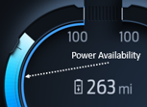  (Follow program specific graphics)
All Other Cases |  |  | Gauge with No Fill

F-REQ-386618/A-Regen Threshold Box Color (Default- All programs except Cx727)
If power gauge fill in Regen area is within Regen threshold (PwWhlLvl_pc_dsply < EffRgenThresh_Pc_Dsply) then Power Gauge fill will be Green color and When PwWhlLvl_pc_dsply > EffRgenThresh_Pc_Dsply, only the portion that’s less than the threshold is green and the rest of the fill is white.

Operational  _Mode | PwWhllvl_Pc_Dsply | Comparison | Power Gauge Fill in Regen area
Normal/Crank | Above 0 to 102.4 | X | Blue  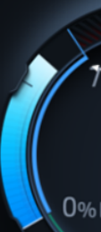
Normal/Crank | 0 to -102.2 | EffRgnThres_Pc_Dsply  >  PwWhllvl_Pc_Dsply | Green  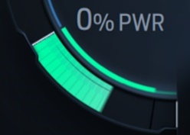
Normal/Crank | 0 to -102.2 | EffRgnThres_Pc_Dsply  <  PwWhllvl_Pc_Dsply | White  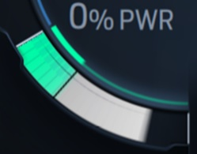

F-REQ-389214/A-Power Gauge Animation

Operational  _Mode | PT_Hyb_Cfg2 | RgenAnimation_B_Dsply  Signal | Power Gauge Animation
Normal/Crank | 0x1  (BEV) | 0x1  (Active) | ON  (Follow program specific graphics)
All Other Cases |  |  | OFF
Note: Follow HMI specification for smooth transition during enter/exit in animation.

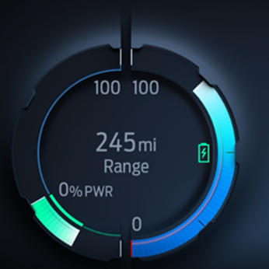
Animation On Animation Off

Operation Description (supports algorithm flowchart /state diagram)

F-REQ-384920/B-Opmode Req_1
Power gauge fill on positive side shall not overlap or exceed with Power availability (Gray Shaded area). If CAN value of PwWhllvl_Pc_Dsply signal is more that available fill area, it should clip it to maximum available area without overlapping with power availability fill.

F-REQ-384921/A-Opmode Req_2

The Power Gauge shall sample the PwWhllvl_Pc_Dsply Signal at the predefined message's periodic rate.

F-REQ-384922/A-Opmode Req_3

The cluster shall use Power Gauge Indication to update the Power Gauge pointer position every 100 msec or less.

F-REQ-384923/B-Opmode Req_4
Power Gauge symbol will change color in sync with Gauge fill color. The icon changes color from Blue to Green depending on PwWhllvl_Pc_Dsply signal. When it’s negative, it’s green and blue when it’s positive. Please refer HMI specifications for color details.


e.g. Cx727 Symbol (for reference only)


e.g. P702 Symbol (for reference only)

F-REQ-389219/A-China Regulation - e.g. Calm Screen IOD
Power gauge must always be shown for China variation (China BEV/xHEV Function = China(0x1)) and cannot be inhibited by any screen (e.g. Calm screen IOD).

FS-REQ-384993/A-Function Safety Classification (EMC)

B

NVM-REQ-384927/C-Memory Storage

Parameter Name | Description | Value at Battery Connect | Value at Module Wake-up
Operational_Mode | 4 state indicators for cluster operational mode | Limited | Limited or Normal or Crank
PwWhllvl_Pc_Dsply | CAN input received by the cluster to indicate Power delivered to the wheels. | 0x0 | 0x0
BattTracPw_Pc_Avail | CAN input received by the cluster to indicate available power | 0x0 | 0x0
EffRgenThres_Pc_Dsply | CAN input received by the cluster to indicate Regen power | 0x0 | 0x0
RgenAnimation_B_Dsply | CAN input received by the cluster to determine Animation status | 0x0 | 0x0
Power Gauge  Indication | MC Center Display of Power Gauge Indication | No Fill | No Fill
Power Availability Indication | MC Center Display of Available Power | No Fill | No Fill
Regen Power Indication | MC Center Display of Regen Power | No Fill | No Fill
Power Gauge Animation | MC Center Display of Power Gauge Animation | OFF | OFF
PT_Hyb_Cfg2 | State indicator for feature presence controlled via CAN at EOL at VO plant. Set to Disabled at Cluster Supplier Manufacturing Plant | Use Stored Value | Use Stored Value
China_BEV_  _xHEV_Cfg | State indicator for feature presence controlled via CAN at EOL at VO plant. Set to Disabled at Cluster Supplier Manufacturing Plant | Use Stored Value | Use Stored Value

Prove Out

No

Error Handling

None.

Missing Message Strategy

The signals will be declared missing as per the Diagnostics section of this SPSS.

DTCs states and history will be determined as per the Diagnostics section of this SPSS.

Diagnostics

Self Test

None

Engineering Test Mode

Reference section “Dealer / Engineering Test Mode (ETM)”

Part II Performance

Reference Part II Diagnostic Specification

Supported Diagnostic DIDs (Service $22 and $2F)

Number | DID / CommonID Name | DID Type

DTC-REQ-384930/A-Supported Diagnostic Trouble Codes (DTCs)

DTC | Description | When Logged
C11100 | Lost Communication with Battery Energy Control Module “A” | Missing Message for 5 seconds or more

DCR-REQ-384931/A-DID DExx

Block  Num | Block Description | Byte(s) | Bits | State: Description | "0" | "1" | Default | Comments/Information
PACKETED BLOCKS
$09 | Option Content (B&A) |  | 3 | PT Hybrid2(PT_Hyb_Cfg2)  0x0 = Non-Hybrid  0x1 = BEV  0x2 = FHEV  0x3 = PHEV  0x4 = MHEV |  |  | 0x0 | $09
$09 | Option Content (B&A) | * | * | China BEV/xHEV Function | Not China | China | China | For China (Peoples Republic of China) must be set to China for compliance to China reg GB/T 4094.2-2005. Taiwan MUST be set to Not China.
 | *Byte and bit location to be identified in Part II Specification for this cluster

Reference Specification

Revision History
SPSS Module Revision History

Revision Level | Name | Change Description | Date
1.0 | H. Sharma | Initial Release. Feature owner: Charbel Bouery  This feature was requested in DICC on 01/30/2020 and approved offline on 02/27/2020 by Scott Watkins for new STSS creation. | 03/23/2020
1.1 | H. Sharma | This is second part of change request for P702-BEV brought to DICC on 01/30/2020 and approved offline on 02/27/2020 by Scott Watkins for new STSS creation. DICC tracking #495. Changes are marked in Turquoise color.  Version 1.0 was specific to Cx727 and this version is for P702 and other future programs.  - Section 1.1 Functional Description is updated to add new signal.  - Section 1.2.1 Interface Context Diagram is updated to add new signal as input and Regen Power Indication as output.  - New section 1.2.2.2.3 for new CAN signal ‘EffRgenThres_Pc_Dsply’ added.  - Section 1.2.3 IR-REQ-385038, Regen Power Indication is added to outputs.  - Section 1.3.3.2 Indicator Graphics / Display Format is updated to P702-BEV sample graphics.  - Section 1.3.5.1.2 F-REQ-385041 is updated to add new signal for Regen Indicator.  - Section 1.3.5.1.3 and 1.3.5.1.4 are marked Cx727 specific.  - Section 1.3.5.1.3 F-REQ-384918/A-Gauge Indication for Power Gauge with Regen is updated to remove dependency of Power availability signal.  - New section 1.3.5.1.5 Gauge Indication for Power Gauge with Regen is added as default option.  - New section 1.3.5.1.6 Gauge Indication for Regen Power Indication is added as default option.  - New section 1.3.5.1.7 Gauge Indication for Power Availability Indicator is added as default option.  - Section NVM-REQ-384927/A-Memory Storage is updated to add new signal and Regen Power Indicator. | 04/22/2020
1.2 | H. Sharma | This update was requested by Charbel Bouery from EPE team through email and approved offline on 04/29/2020 by Scott Watkins. There are two parts of this update:  - Always allow Power Gauge display for China variation  - Turn On/Off animation based on CAN signal  DICC tracking #549. Changes are marked in Yellow color.  - Context Diagram updated to add new CAN signal ‘RgenAnimation_B_Dsply’  - New CAN signal added to section, 1.2.2.2 MUX messages on the CAN Network Input.  - ‘Power Gauge Animation’ is added to Context diagram and output section.  - New section 1.3.5.1.9 F-REQ-389214/A-Power Gauge Animation is added to explain animation behavior.  - New section 1.3.5.2.5 F-REQ-389219/A - China Regulation - e.g. Calm Screen IOD is added.  - Section 1.3.5.4 NVM-REQ-384927/B-Memory Storage is updated to add new CAN signal and animation output. | 05/20/2020

